**Name: Ashlymol Thomas**

**Rollno: 19**

**20INMCA332 – Open-Source Platforms – Lab Series 2**

**Q1.** Execute commands for creating a directory, create 3 subdirectories inside it, create 3files with content. List all details separately. Execute a shell script to find whether a given number is prime or not. Upload both programs with output to GitHub and share to corresponding staff

Ans:

Creating the directory and 3 subdirectory

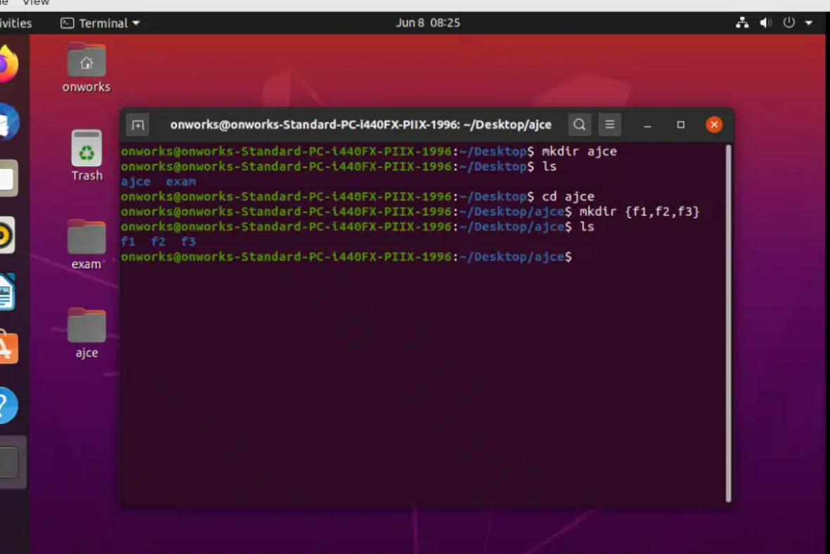

Creating 3 files

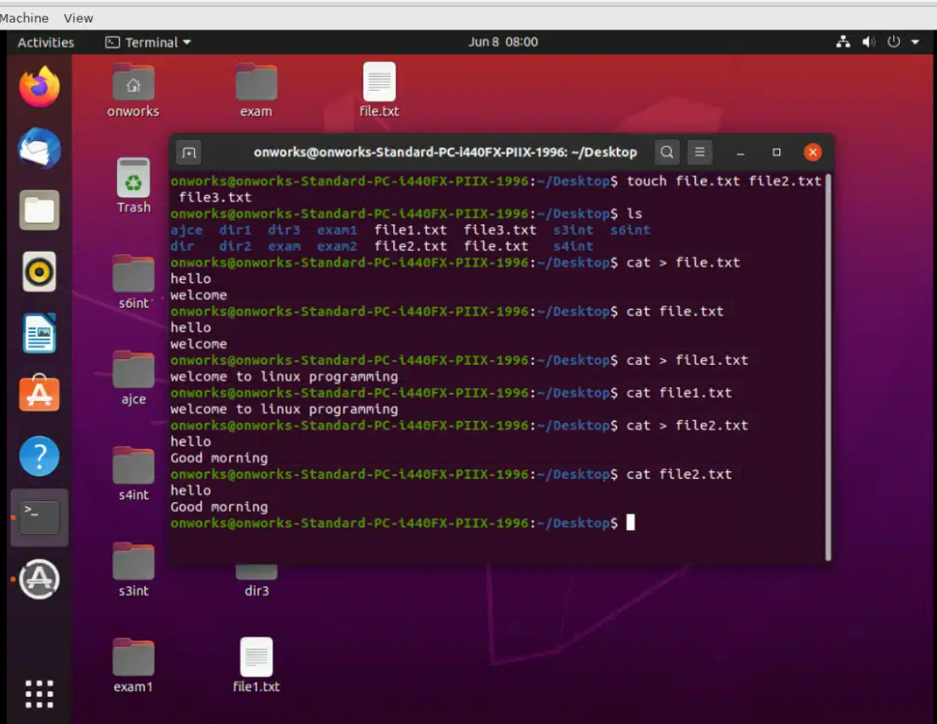

Prime or not

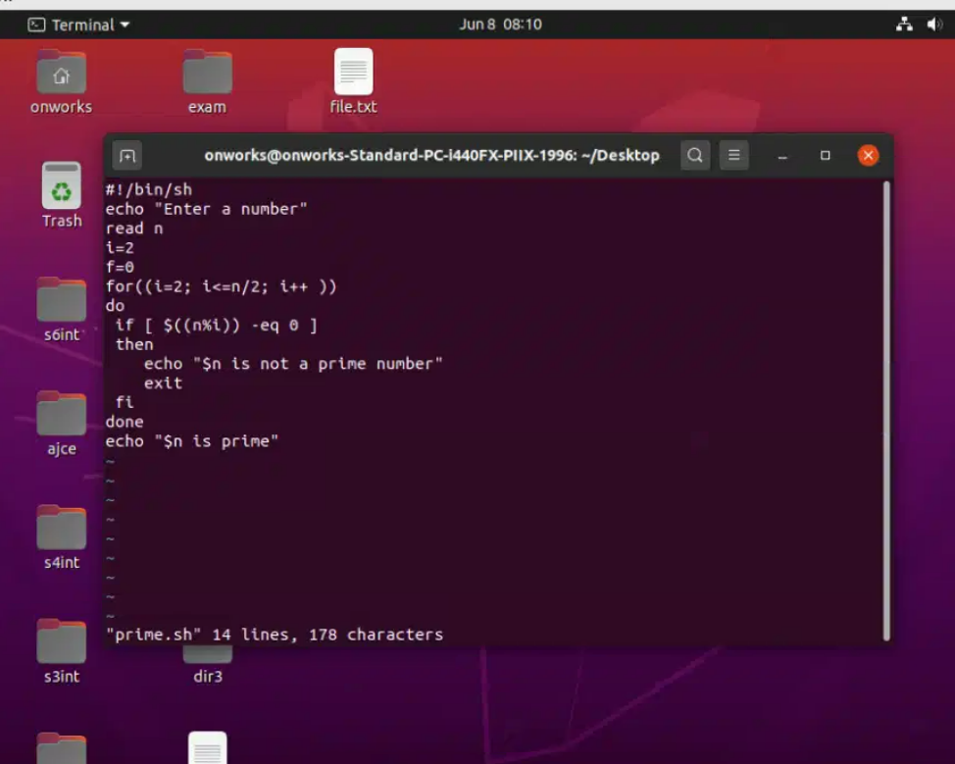

Output

